- Airlines database
Create database airlines
Use database airlines
2.
CREATE TABLE air_passenger_profile (
profile_id VARCHAR(10) PRIMARY KEY,
password VARCHAR(10) NOT NULL,
first_name VARCHAR(10) NOT NULL,
last_name VARCHAR(10) NOT NULL,
address VARCHAR(100),
mobile_number BIGINT UNIQUE,
email_id VARCHAR(30) UNIQUE
);
CREATE TABLE air_flight (
flight_id VARCHAR(10) PRIMARY KEY,
airline_id VARCHAR(10) NOT NULL,
airline_name VARCHAR(30) NOT NULL,
from_location VARCHAR(20) NOT NULL,
to_location VARCHAR(20) NOT NULL,
departure_time TIME NOT NULL,
arrival_time TIME NOT NULL,
duration TIME,
total_seats INT CHECK (total_seats > 0)
);
CREATE TABLE air_flight_details (
flight_id VARCHAR(10),
flight_departure_date DATE,
price DECIMAL(8,2) CHECK (price >= 0),
available_seats INT CHECK (available_seats >= 0),

CONSTRAINT pk_flight_details
PRIMARY KEY (flight_id, flight_departure_date),

CONSTRAINT fk_flight_details_flight
FOREIGN KEY (flight_id)
REFERENCES air_flight(flight_id)
ON DELETE CASCADE
);
CREATE TABLE air_ticket_info (
ticket_id VARCHAR(10) PRIMARY KEY,
profile_id VARCHAR(10) NOT NULL,
flight_id VARCHAR(10) NOT NULL,
flight_departure_date DATE NOT NULL,
status VARCHAR(10)
CHECK (status IN ('BOOKED', 'CANCELLED', 'PENDING')),

CONSTRAINT fk_ticket_profile
FOREIGN KEY (profile_id)
REFERENCES air_passenger_profile(profile_id),

CONSTRAINT fk_ticket_flight_details
FOREIGN KEY (flight_id, flight_departure_date)
REFERENCES air_flight_details(flight_id, flight_departure_date)
);
CREATE TABLE air_credit_card_details (
profile_id VARCHAR(10),
card_number BIGINT,
card_type VARCHAR(10),
expiration_month INT CHECK (expiration_month BETWEEN 1 AND 12),
expiration_year INT CHECK (expiration_year >= YEAR(GETDATE())),

CONSTRAINT pk_credit_card
PRIMARY KEY (card_number),

CONSTRAINT fk_credit_profile
FOREIGN KEY (profile_id)
REFERENCES air_passenger_profile(profile_id)
ON DELETE CASCADE
);
Queries
1.SELECT
f.flight_id,
f.from_location,
f.to_location,
DATENAME(MONTH, fd.flight_departure_date) AS Month_Name,
AVG(fd.price) AS Average_Price
FROM air_flight f
JOIN air_flight_details fd
ON f.flight_id = fd.flight_id
WHERE f.airline_name = 'ABC Airlines'
GROUP BY
f.flight_id,
f.from_location,
f.to_location,
DATENAME(MONTH, fd.flight_departure_date),
MONTH(fd.flight_departure_date)
ORDER BY
f.flight_id ASC,
MONTH(fd.flight_departure_date) ASC;
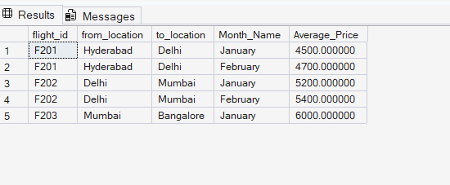
2.
SELECT
p.profile_id,
p.first_name,
p.address,
COUNT(t.ticket_id) AS No_of_Tickets
FROM air_passenger_profile p
JOIN air_ticket_info t ON p.profile_id = t.profile_id
JOIN air_flight f ON t.flight_id = f.flight_id
WHERE f.airline_name = 'ABC Airlines'
GROUP BY p.profile_id, p.first_name, p.address
HAVING COUNT(t.ticket_id) = (
SELECT MIN(cnt)
FROM (
SELECT COUNT(*) cnt
FROM air_ticket_info ti
JOIN air_flight af ON ti.flight_id = af.flight_id
WHERE af.airline_name = 'ABC Airlines'
GROUP BY ti.profile_id
) x
)
ORDER BY p.first_name;


3.
SELECT
f.from_location AS From_Location,
f.to_location AS To_Location,
DATENAME(MONTH, fd.flight_departure_date) AS Month_Name,
COUNT(fd.flight_departure_date) AS No_of_Services
FROM air_flight f
JOIN air_flight_details fd
ON f.flight_id = fd.flight_id
GROUP BY
f.from_location,
f.to_location,
DATENAME(MONTH, fd.flight_departure_date),
MONTH(fd.flight_departure_date)
ORDER BY
f.from_location ASC,
f.to_location ASC,
MONTH(fd.flight_departure_date) ASC;
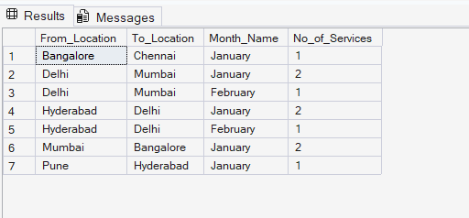
4. SELECT
p.profile_id,
p.first_name,
p.address,
COUNT(t.ticket_id) AS No_of_Tickets
FROM air_passenger_profile p
JOIN air_ticket_info t ON p.profile_id = t.profile_id
JOIN air_flight f ON t.flight_id = f.flight_id
WHERE f.airline_name = 'ABC Airlines'
GROUP BY p.profile_id, p.first_name, p.address
HAVING COUNT(t.ticket_id) = (
SELECT MAX(cnt)
FROM (
SELECT COUNT(*) AS cnt
FROM air_ticket_info ti
JOIN air_flight af ON ti.flight_id = af.flight_id
WHERE af.airline_name = 'ABC Airlines'
GROUP BY ti.profile_id
) x
)
ORDER BY p.first_name;
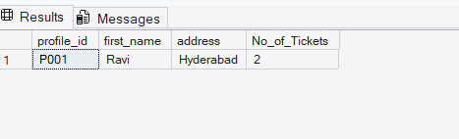
5.
SELECT
p.profile_id,
p.first_name,
p.last_name,
f.flight_id,
f.departure_date,
SUM(b.no_of_tickets) AS No_of_Tickets
FROM Passengers p
JOIN Bookings b ON p.profile_id = b.profile_id
JOIN Flights f ON b.flight_id = f.flight_id
WHERE f.departure_city = 'Chennai'
AND f.arrival_city = 'Hyderabad'
GROUP BY
p.profile_id,
p.first_name,
p.last_name,
f.flight_id,
f.departure_date
ORDER BY
p.profile_id ASC,
f.flight_id ASC,
f.departure_date ASC;
6.SELECT
f.flight_id,
f.from_location,
f.to_location,
fd.price AS ticket_price
FROM air_flight f
JOIN air_flight_details fd
ON f.flight_id = fd.flight_id
WHERE MONTH(fd.flight_departure_date) = 1
ORDER BY f.flight_id;
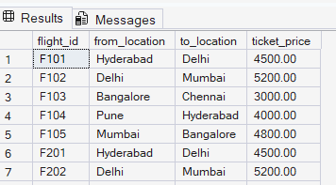
7.
SELECT
f.flight_id,
f.from_location,
f.to_location,
AVG(fd.price) AS Price
FROM air_flight f
JOIN air_flight_details fd
ON f.flight_id = fd.flight_id
GROUP BY
f.flight_id,
f.from_location,
f.to_location
ORDER BY
f.flight_id ASC,
f.from_location ASC,
f.to_location ASC;
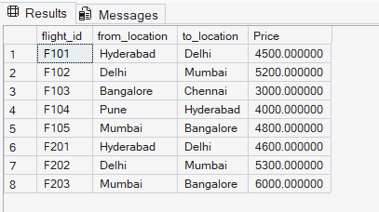
8.
SELECT DISTINCT
p.profile_id,
p.first_name + ',' + p.last_name AS customer_name,
p.address
FROM air_passenger_profile p
JOIN air_ticket_info t
ON p.profile_id = t.profile_id
JOIN air_flight f
ON t.flight_id = f.flight_id
WHERE f.from_location = 'Chennai'
AND f.to_location = 'Hyderabad'
ORDER BY p.profile_id ASC;
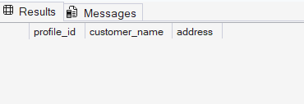
9.
SELECT profile_id
FROM air_ticket_info
GROUP BY profile_id
HAVING COUNT(*) = (SELECT MAX(cnt)
FROM (SELECT COUNT(*) AS cnt
FROM air_ticket_info
GROUP BY profile_id) AS t)
ORDER BY profile_id ASC;
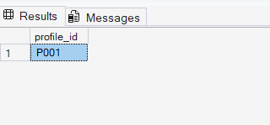

10.
SELECT
f.flight_id,
f.from_location,
f.to_location,
COUNT(t.ticket_id) AS No_of_Tickets
FROM air_flight f
JOIN air_ticket_info t
ON f.flight_id = t.flight_id
WHERE f.airline_name = 'ABC Airlines'
GROUP BY
f.flight_id,
f.from_location,
f.to_location
HAVING COUNT(t.ticket_id) >= 1
ORDER BY f.flight_id ASC;
